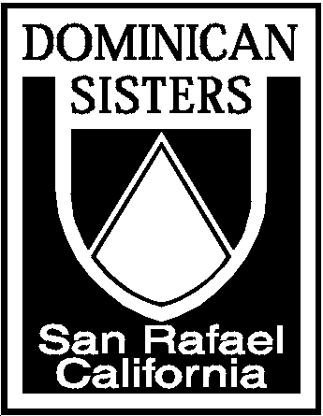Dominican Sisters of San Rafael

1520 Grand Avenue

San Rafael, CA 94901-2236
(415) 453-8303 fax (415) 453-8367
www.sanrafaelop.org

Corporate Stance for Compassionate Immigration Reform

We, the Dominican Sisters of San Rafael, are committed to upholding the God-given dignity of every person made in the image of God. Because we value family unity, justice, equity, and the humane treatment of all persons, and because we recognize and appreciate the contributions of immigrants to our society, we declare our support for compassionate immigration reform. We want our undocumented immigrant brothers and sisters to have a clear path to legal permanent residence and citizenship, and to be able to keep their families together. We support the U.S. and Mexican Catholic bishops in their pastoral letter, “Strangers No Longer: Together on the Road to Hope,” as they call for the reform of the current immigration system.
Therefore we pledge to support our immigrant brothers and sisters by:

1. advocating on behalf of immigrant rights, especially for the protection of workers’ rights, the restoration of due process and the reform of detention policies;
2. becoming aware of employment issues raised by current U.S. immigration policies and the consequences of NAFTA;
3. challenging the racism of U.S. border policies, focused on our southwest border;
4. advocating on behalf of our immigrant women and children, victims of domestic violence, sexual abuse and stalking.

We commit ourselves to education, advocacy, and action, grounded in Catholic Social Teaching so that our efforts might contribute to a welcoming society and full integration of immigrants into our country. We commit ourselves to reaching out to our immigrant brothers and sisters through our ministries in preaching, health care, education, pastoral and social services.

Adopted June 2009

